Golden Rules of Trading
- Never open a position without knowing your initial risk (R). This is determined by your initial stop loss.
- Define profits and losses of your trades as a multiple of your initial risk.
- Limit your losses to 1R or less.
- Make sure your profits are on average bigger than 1R.
Summary of rules 1-4: “cut your losses short and let your profits run”.
- Understand your trading system in terms of the mean (the average R) and the standard deviation (variability of results) of your R-multiples.

1R = how much you will lose per unit of your investment

Your loss can easily exceed 1R e.g. due to an opening gap.

If you don’t know your initial risk (e.g. it is a variable and it is impossible to say what it would be at the onset), you can use average loss as 1R.

R varies from trade to trade. However, if you risk x% of equity on your trade, you can tell what y% profit or loss you can expect on each trade.

Mean R-multiple is the expectancy of your system. Expectancy tells you what to expect of our system in terms of R-multiples over many trades.
Example: if expectancy of your system is 0.33R, than you know that after 20 trades you should be up by ~6.6R.
Expectancy tells you how much $ you can expect to earn per 1$ risked. You can also express expectancy with respect to R (see above).

Expectancy = (AvgP*%P-AvgL*%L)/AvgR

SQN = Expectancy/StdDevR * sqr(NumOfTrades)

When using SQN for evaluation of several systems, it is recommended to set number of trades to 100 to normalize the results. The other reason supporting such approach is that when you have too many trades, you could strongly overestimate the quality of the system.
Therefore if you have over 100 trades, a good approach is:

SQN = Expectancy/StdDevR * 10

The formula to calculate SQN is basically a statistical t-score, comparing one sample against an assumed mean of zero. If you have a positive expectancy, the t-score shows whether or not your results are significantly different from a zero or negative return. If there is a 95% possibility that it is different, then you can reject a hypothesis that it has a negative or zero return on the average. Generally, the larger the SQN, the more likely is that you can reject that hypothesis.
IMPORTANT: The t-score makes an assumption that your data fit a normal bell curve. Most trading systems have fat tails, e.g. one or two big trades that make most of the profits. This has to be taken into consideration. Nevertheless, the t-score will at least give you a rough estimate of the system quality.

Below are some t-scores at various percentiles to use at your own assessment of the system.

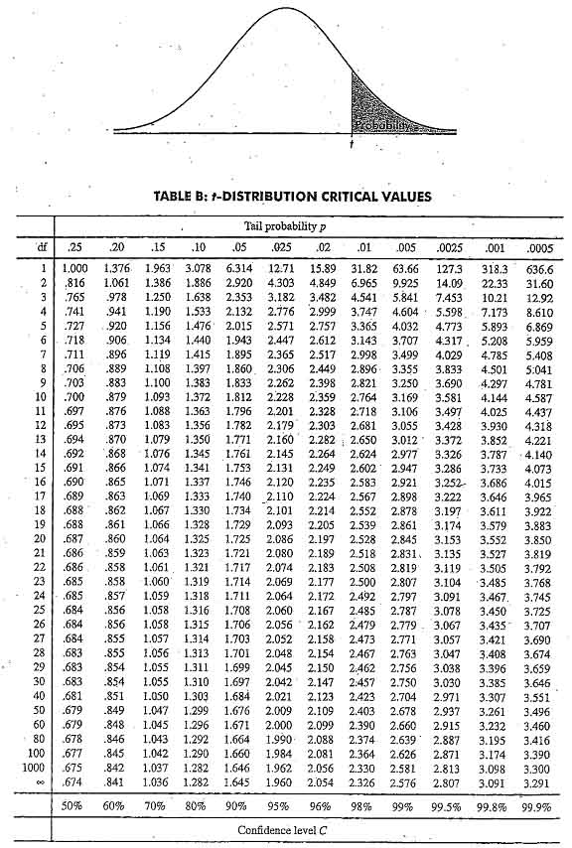

Minimum size to reflect statistical characteristics of population is 30. However, in trading you must know that your sample represents the real population of trades – and it won’t until your sample contains all six types of markets:
- Up-volatile markets
- Up-quiet markets
- Flat-volatile markets
- Flat-quiet markets
- Down-volatile markets
- Down-quiet markets
While you might not trade your system in all six kinds of markets, you need a large sample of trades (ideally more than 100, but at least 30) from each of these six markets to get an adequate idea of how your system will perform. If you don’t meet these criteria, then you really have no idea what to expect from your system.

Mutually exclusive set of rules / characteristics describing each of 6 above markets has to be defined

You need to check how many simultaneous trades your system could make. You need to be careful here. If your system generates 20 that you have open at one time, what will happen to all of them when the whole market crashes? This topic is addressed under portfolio heat and group heat.

A good rule of thumb might be to look for a system that produces SQN of at least 2.5 before trading it. You might also look at the ratio between expectancy and the standard deviation of R-multiples. If that ratio is 0.25 or better, then you have the makings of a potentially good system.

Even if the R-multiples generated by your system during testing accurately represent what your system can do, you are still missing a lot of information. You have to answer following questions:
- Does my sample accurately represent the kind of results I can expect from my system?
- Is this system valid? Does it really do what is supposed to do?
- If answer to both above question is “Yes”, what can I expect from the system in the future? What will happen in terms of drawdowns? What can I expect to earn? How variable will my performance be?
- What kinds of markets will my system work in?
- Does my testing assume that one trade is made at a time? If so, what will the implications be on real trading if I have a portfolio of multiple, correlated trades?
- With the objectives I have in mind and the results of my testing, how should I position size this system to adequately meet my objectives?

You can do a Monte Carlo simulation of your system to determine if a sufficient number of samples make money. Let’s say you have a sample of 30 trades. You have to determine what happens when you sample 100 such 30-trade samples. What percentage of these samples makes money? Are you happy with those results? If 95% of your samples made money, then you would definitely have a statistically significant system. You can choose another significance level, however at some point you have to decide that isn’t good enough and isn’t worth trading.

How to implement Monte Carlo simulation in MQL5?? MT5 has its own strategy tester. Possible solution: use all the output trades from the strategy tester as an input (tbd – how to fetch these trades?) in the OnTester() event handler, and run the Monte Carlo simulation there.

You can get a better idea of what might happen in the future by taking your data sample and plugging the R-multiple distribution into a Monte Carlo simulator to determine several things:
- What can I expect from my system in terms of drawdowns? What is the maximum drawdown in terms of R? What is the probability of getting a drawdown as big as 20R in my sample of 100 trades? How long might that drawdown last?
- How will I know what to expect in terms of losing streaks? What is the chance of getting a losing streak of 10 in a row or bigger with this system in 100 trades?
- How will I know when this system is broke or no longer working?
- Given the results of the simulation, how can I position size this system to adequately meet my objectives in trading it?

What you have to know about your system
- For every trade, you have a predetermined worst-case exit, which determines your initial risk or R.
- The results of your trading can be expressed as a ratio of an initial risk or R and what you get is your results expressed as a set of R-multiples.
- Every system can be classified by the R-multiple distribution it generates, with the mean telling you the expectancy of the system and the standard deviation telling you the variability of your potential results.
- You can then evaluate your system by its System Quality Number (SQN).
- You want systems that will make money and systems with high SQN will do that if your data is reliable (consistent with what you’d expect from your system) and your sample is representative.
- You should know how your system will perform in each of six major market types. Often you might find that a so-so system overall is an excellent system under the right market conditions.
- Once you have the R-multiple distribution that your system generates, you really only have one sample of its performance, but if you have enough data in the sample from enough markets, then it probably does represent the population of R-multiples that your system will generate.
- Now you need to simulate that performance to determine what to expect from your system in the future. What percentage of the time will X trades make money? What’s the average worst-case drawdown against you in terms of R? How big are the losing streaks? What kind of gains can you expect? What’s the ratio of gains to drawdowns?
- Once you’ve completed all of these steps, then you will know what to expect from your system in the future. Most importantly, you should know that you can live through the worst-case scenarios ahead of you, including that all of your trades will move against you at once. However, a critical aspect to helping you do that is position sizing.

In reality, the more transformations you do on data, the less likely it is to represent the market.

The more winners you have in a distribution, the more you can risk and the lower your chances will be of having much bigger than expected drawdown. And this typically occurs because the standard deviation of your R-multiple distribution becomes smaller. In addition, when you don’t have any bad losses in your distribution, you can risk a lot more. For example, if all your losses are 1R, having zero variability in your losses allows you to more than double the risk and still have almost no risk of ruin. If the standard deviation is high, which might occur when you have few large R-multiples producing much of your results, then your SQN will be lower and it will be more difficult to use position sizing to meet your objectives.

Losing streak as a function of winning percentage (simulated over 100 trades 20000 times)
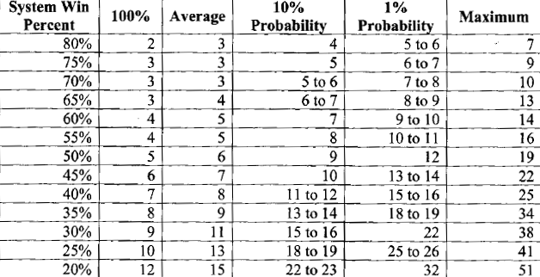

In most trading situations, maximum bet size is 3-4%.

CPR Model in position sizing
P=C/R
C – amount of total cash (equity) to risk, e.g. 1% of 50,000$ → 500$
R – risk per unit, e.g. buy stock for 50$ and risk 5$ per share
P – position sizing: how many units to buy → C/R=100

Equity models
Core Equity = cash available after subtracting the amount allocated for open positions
Total Equity = core equity + value of open positions
Reduced Total Equity = core equity + profit of open position(s) locked with a trailing stop

Position sizing models

Units per fixed amount of money
Calculate position size by trading 1 unit per every X cash in account, e.g. one contract per 50000$ of your total equity.
Disadvantages:
Inefficient exposure increase.
Possibility of taking too risky trades on volatile market.

Equal units/equal leverage
Divide your equity e.g. in 5 or 10 parts and invest each in different stock. Allows you to give each investment an approximately equal weighting in your portfolio.
Disadvantages:
Limits your possibility to let your profits run.
Allows position size increase very slowly.
If volatility of one product is much bigger than volatility of the other product, it has much bigger impact on your account although amount of money invested in both products is equal.

Percent margin
Limit a margin available for each trade to the percentage of your equity. E.g. you have 50,000$ equity and decide to limit the margin on each trade to 5%, which means that you allow 2,500$ margin per trade.
You can also limit the total margin of your account to some value, e.g. 30%. If you do that, the margin on all open positions cannot exceed 30% of your equity.
Disadvantages:
Margin amounts can change daily for each contract, so you have to keep track of them.
Margin method doesn’t necessarily give you equal exposure across all positions (you could have two positions with equal margin and still have tremendous differences in their volatility exposure).

Percent volatility
Volatility = daily high – daily low OR use ATR
If you equate the volatility of each position that you take by making it a fixed percentage of your equity, then you are basically equalizing the possible market fluctuations of each portfolio element you are exposed to in the short term.
Example: 10-day volatility is 3 points. Each point is worth 100$ so volatility is 300$ per contract. If you have 50,000$ account and want to risk 2%, you basically risk 1000$. Your position size is 1000$/300$ = 3.33 contracts.
If you use volatility in your position sizing, you might also want to limit the total amount of volatility to which your portfolio is exposed at any one time. 5-10% is a reasonable number.
IMPORTANT: Remember that in this method, risk (e.g. stop loss) is irrelevant to position sizing as you are focusing on the volatility.

Percent risk (fixed fractional position sizing)
Your overall risk using this method depends upon the size of the stops you’ve set to preserve your capital. Example: you decide to risk 2% of 50,000$ equity on a trade and use a stop-loss of 5$. This means you can purchase 1000$/5$=200 units.
If you are trading other people money, you probably should risk less than 1% per position. If you trade your own money, usually anything under 3% is probably fine if your system’s SQN is good enough.

Group control
As most trades are not independent, a group of products might tend to move in the same direction at the same time. Thus, your goal to optimize your position sizing is to minimize the number of highly correlated positions in your portfolio at any given time. You could do this by pre-selecting a limited number of products in which to invest or trade. This is the portfolio selection part of system design. However, you can also accomplish such diversification by having a position sizing algorithm limiting your total group exposure by using one of the methods presented so far. For example, you could limit the amount of leverage in any one group. You could also limit the amount of risk, volatility, margin or total number of units of exposure that you have in any one group. This has the advantage of limiting your group exposure, while avoiding the possibility of missing a good opportunity because it is not a part of the portfolio that you have pre-selected to trade.
Example: if you allow 1% risk on each trade and it turns out that you have a portfolio of bonds or currencies, you could limit a total group risk (group heat) to 3%, thus being allowed to open positions in 3 currencies or 3 bonds.

Portfolio heat
When the stock market goes up, all of your investments will tend to rise. When the stock market goes down, all of your investments will tend to fall. In addition, the entire market will occasionally be exposed to unexpected price shocks (crashes). Price shocks will wipe you out if you are highly leveraged and your portfolio heat is too high. As a result, it’s important to limit the total risk to which your portfolio is exposed. This measure is called portfolio heat. Most great traders would argue that probably 20-25% portfolio heat is a maximum level. However, portfolio heat should also depend on the quality of your system – a system with higher SQN could tolerate bigger portfolio heat than a system with lower SQN.
Rough guidelines for the maximum portfolio heat you should use:
Look at your largest possible loss in your system’s R-multiple distribution and make sure your maximum portfolio heat is less than 100% divided by this largest possible loss (maximum negative R). Example: if your largest loss is 5R, your maximum portfolio heat should be <20%.

Rough guidelines for the maximum portfolio heat based upon your system’s SQN
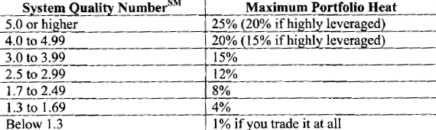

When you determine the portfolio heat, work backwards to determine the individual risk on any given position. How many positions are you likely to have at one time? Take your maximum number of positions and divide that into the number you’ve just calculated for your portfolio. That’s probably a good estimate for the maximum amount of risk you should assume for a single position. However, these guidelines also assume that you are going for maximum gains in your portfolio, not other criterion.
Let’s say that you trade a maximum of 10 positions at a time. With a SQN of 5.0 or higher, you could probably have a 2.5% risk in each position if you are not highly leveraged. With only five maximum positions, you could go up to 5% risk if you are not highly leveraged. Both of these estimates would be exceptional risk for someone who wants maximum return with a minimum risk of ruin. And even with an exceptional system, you are still flirting with disaster with these numbers. If you have a weak but tradeable system (e.g. with SQN from 1.7 to 2.49), then your maximum risk per position with 10 positions should be no more than 0.8% per position. And if your SQN falls below that and you are willing to trade it, then I wouldn’t suggest more than a few positions with 1% risk or less. That way, even under terrible conditions, your portfolio will not damage you extensively.

Equity crossover position sizing
Increase position size when your equity curve crosses some moving average and reduce (or even eliminate) position size when your equity curve crosses below some moving average. If you want to use such position sizing method, the parameters that you should set are:
- The number of periods or trades of the moving average
- The size of the increment of position size (e.g. 20%, 50%, 100%)
- The size of the decrement of position size (e.g. 20%, 50%, 100%)

Optimal position size is a function of each of the following:
- Your R-multiple distribution, characterized by its expectancy, standard deviation and SQN.
- The worst-case loss in that distribution.
- The number of trades.
- Your definition of success (what capital increase you would like).
- The probability of achieving that success.
- Your definition of ruin (what kind of drawdown from the starting equity is intolerable at the end of X trades).
- The probability of achieving that level of drawdowns.

Conclusion:
Expectancy, R-multiple distribution, worst-case loss, SQN and percentage of winners all go into determining the optimal position size. When the expectancy is constant, then the most important factors are percentage of winners and SQN.

Market money methods
Perhaps the best way to go for top returns is to distinguish between your starting equity and your profits (market’s money). You can’t do this if you are trading with other people’s money because they typically get upset – especially when you give back open profits. However, if you are willing to take the mental step of calling your own profits “market’s money”, then you personally can apply these great money making techniques. You can design a system that risks very little of your starting capital, but risks the market’s money at optimal target risk percentage. The real advantage of such system is that as soon as you move into profitability, your ability to make more profits goes up dramatically – but so does your risk.

Most of the differences in market’s money techniques involve determining when the market’s money become your money and is traded at a lower risk level. Below is a list of 5 methods that you can use:
- Percentage gain – suppose your goal is to make 100% each year. However, once you are up 50%, you don’t want to give it back. Thus, you might reset market’s money to become your money. This will make it harder to reach your objective, but it also gives you a stronger base from which to reach that objective. That is, it is much easier to make a 100% gain on the year once you are up 50% than from your baseline.
- At important calendar dates – for example, you might want market money to become your money at the end of the month or quarter. If you are managing other people’s money, then you can still use this technique if you decide that the point at which you report your profits to your investor (whether weekly, monthly or quarterly) is the date that market’s money is reset. That means that every time your investors learn about profit, market’s money algorithm will not be in use (they will be converted into your profit).
- Monetary goal reached – not recommended as most people perform very poorly when they are concerned about particular amount of money.
- After X trades.
- Based upon some mathematical formula – there are many ways we could calculate market’s money mathematically; however, it really represents a whole constellation of methods based upon how you reset market’s money to become core equity or your base money.

Scaling In Techniques
A profitable position scaling technique that allows to build capital quickly is through pyramiding and stop adjustment. Example:
Initial capital = $100,000
Stop-loss = 3 x daily volatility V
Total Risk = up to 20% equity at a time (using reduced total equity model)
up to 5 open positions at once → up to 4% risk per position, but not instantly - 2% initial risk, building up to 4% as profits grow

BUY corn $3.025, V = 3.5 cents
initial risk on 1st position = 2% * $100,000 = $2,000
SL(1) = 10.5 cents @ $2.92 = $525 risk per contract
PS(1) = PS(Tot) = $2,000/$525 = 3 contracts
pyramiding algorithm: risk another 2% every time profit increases by 1V

price moves to $3.06
risk another 2% on 2nd position, SL(2) = 10.5 cents @ $2.955
SL(1) @ $2.955
PS(Tot) = 6 contracts
Total Risk to original equity = Total Risk = 2.63% due to trailing SL adjustment
Reduced total equity = $97,375

V increases to 4 cents → SL = 12 cents = $600 risk per contract
price moves to $3.10
risk another 2% on 3rd position → 2% * $97,375 = $1947.50 → PS(3) = 3 contracts
PS(Tot) = 9 contracts
Total Risk to original equity = $3,375 = 3.375% due to trailing SL adjustment
Reduced total equity = $96,625
Total Risk = $5,100
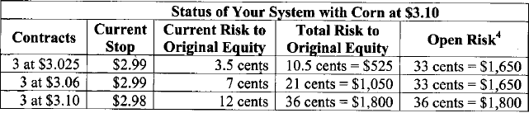

price moves to $3.14
risk another 2% on 4th position → 2% * $96,625 = $1932.50 → PS(4) = 3 contracts
PS(Tot) = 12 contracts
Total Risk to original equity = $3,525 = 3.525% due to trailing SL adjustment
Reduced total equity = $96,475
Total Risk = $7,050
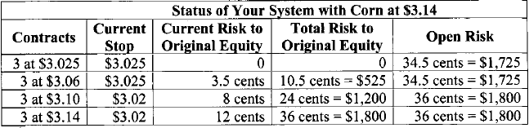

V increases to 6 cents → SL = 18 cents = $900 risk per contract
price moves to $3.20
risk another 2% on 5th position → 2% * $96,475 = $1929.50 → PS(5) = 2 contracts
PS(Tot) = 14 contracts
Total Risk to original equity = $3,600 = 3.6% due to trailing SL adjustment
Reduced total equity = $96,400
Total Risk = $10,200
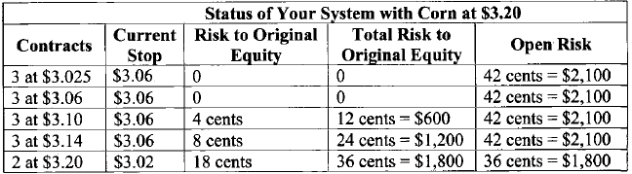

price moves to $3.26
risk another 2% on 6th position → 2% * $96,400 = $1928→ PS(6) = 2 contracts
PS(Tot) = 16 contracts
Total Risk to original equity = $3,400 = 3.4% due to trailing SL adjustment
Reduced total equity = $96,600
Total Risk = $13,150
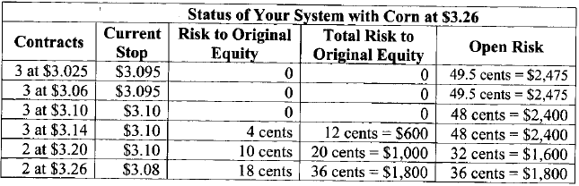

You can offset the risk of excessive moves against your pyramide position e.g. by buying options.
There is a number of variables that you can vary in scaling-in position sizing. These might include initial stop loss, trailing SL method, maximum risk per commodity, equity model, position sizing model. For example, your initial risk and scaling in doesn’t have to be based on volatility, but on R or percentage of R. You can scale in e.g. on successive entry signals – on trend retracements or consolidation breakouts, whenever you move stops to break even, or when your position is up by fixed $ amount.
It is critical that you are aware of the dangers of scaling in:
- limit the total number of scales in that you will make to 3-4
- limit your total open risk and scale out when that limit is exceeded
- consider having take profit targets for scaling in and closing positions when those targets are hit. This is especially important where you are not doing long-term following with the major market trend

Fixed ratio position sizing (FRPS)
FRPS says we will increase position size by one unit as a function of some fixed ratio of the account (delta) – increase position size when your equity increases by the number of current units multiplied by delta.
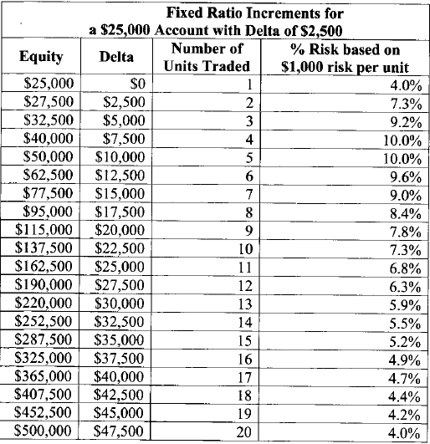
Notice that you initially increment very rapidly and then the process slows down. Once you pass the peak risk level, FRPS has less and less risk. You can continue this until you decide that percent risk position sizing is a better way to go. In fact, it will eventually produce less risk than percent risk model with the same initial risk. Please note that above example is starting with 4%, which is super aggressive, and even goes up from there.
Above table is done with the following assumptions:
  - Each unit carries $1,000 risk.
  - In FRPS your loss potential is limited because when you start to lose, you scale out position size. Adding the “dampening factor” to the equation does this. For example, when your account drops by the prior increment level, you could drop down one unit.
Assumptions necessary to simulate FRPS:
- Initial risk should vary from 0.5% to 2.0%.
- Delta levels similar to what Ryan Jones used should be from 1% to 5%, however with such levels there are much larger risks than percent risk model would allow. (NOTE: try some larger levels of delta).
- Delta in the case of declining equity – trading is not stopped when we are down one delta level from base equity. This means that bet size will get proportionally bigger as the equity draws down, since the minimum bet will be from 1% to 5% of starting (not current!) equity. This differs from the percent risk model, where risk would be a constant percentage of current equity during the drawdown.
- Number of units to use – start trading with x unit(s), e.g. 1 or 3, and increment up as delta levels are reached.
Dampening factor can be much steeper than climbing factor (e.g. equal to 50% of climbing factor).
Delta should be related to the maximum expected drawdown. Thus, you must have a way of doing some basic simulations with your trading system to determine the average maximum drawdown that you will likely achieve in terms of R. Use delta levels based upon what percentage of the maximum drawdown we might be able to tolerate, e.g. 75% MaxDD for increasing and 50% MaxDD for dampening.
Increment level should be set by considering initial capital that the trader is comfortable risking. It should be determined by dividing the acceptable initial capital loss by MaxDD, e.g. if you accept 25% decline from initial capital and MaxDD is 40R, initial risk is 25/40=0.625%. As the expected MaxDD changes, risk factor also changes.
An assumption that produces a large impact on protecting initial capital is that number of traded units can be zero (switching to virtual trading).
A good approach is a possibility of switching from FRPS to a fixed percent risk when it becomes a better alternative. Essentially, you set some switch level (i.e. 100%) at which you either tell the system to switch to percent risk model using the initial risk amount or keep using FRPS, depending on which has the larger bet size. Such approach gives a huge advantage when you have a good system.
Don’t use FRPS if you don’t have SQN of at least 2.5. Otherwise your potential risk of ruin is too high.

Position Sizing approach to limit downside potential
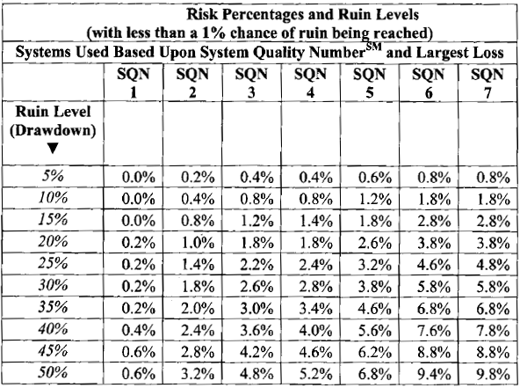

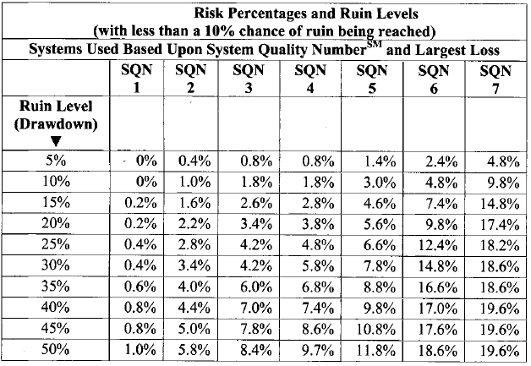

A large portfolio of correlated positions can only tolerate a small amount of portfolio heat if your goal is to avoid ruin.
If you have little tolerance for drawdowns at all and want something like a 1% tolerance on a 10% drawdown, then you must have 1) a superb trading system, 2) very few existing positions at one time or 3) very small risk levels of about 0.2%.

As above risk percentages for avoiding ruin are very low, they offer a very little chance of making significant gains.

Two-tier position sizing
You can use this approach when your investment priorities are to achieve your desired goal, but you still want to make sure that you never achieve ruin. It can be done using following methods:
Using the market’s money – for example, risk less than 1% chance of ruin level on your core equity and the optimal target risk on market’s money.
Optimal goal switch at a critical equity level – at some critical equity level you switch to a different percentage risk on your entire equity, e.g. your 1st risk level is 0.5% and 2nd risk level is 2%.For example, the optimal goal switch might determine that you would switch to 2% risk when you are up 25% with an idea that a drawdown of 20% (which would get you back to break-even) is unlikely.
Obviously, an analogous multiple-tier position sizing can be used.

Scaling out methods
Your exposure could be monitored using any of the position sizing models given or any of the equity models suggested. You can scale out i.e. when your exposure exceeds x% of your equity or when volatility (based upon ATR) exposure on an open position exceeds x% of your equity. Both approaches are very useful in that they tend to smooth equit curve. They allow you to fully participate in a market move until market stops you out. However, as your risk exposure gets bigger, you scale out positions to keep the risk constant. In addition, as the volatility exposure increases, you scale out positions to maintain and limit your volatility exposure. However, I would recommend that you consider both ongoing risk and ongoing volatility with a total equity calculation.

For short-term trading, when you really know what you are doing, scaling out part of the position when you get to break even can be a viable approach.

Position sizing methods to avoid
Below shows why dangerous (e.g. martingale, regression toward the mean) position sizing models should be avoided:
- If your original sample does not represent your system adequately and vastly overestimates its performance, any of such position sizing models will probably lead you to ruin.
- The odds of next sample being a loser do not change, so after a streak of losses you would be accelerating your drawdown
- If you make incorrect judgment about any of risk or drawdown related variables and set them too high, it would lead to ruin

Many authors recommend position sizing method that produce largest average ending equity. The largest average ending equity will usually occur when you risk at a level that will eventually give you about 90% probability of ruin and very low probability of reaching your objective. Consequently, don’t use such techniques.

A risky position sizing tactic is to risk more on a trade that you think has a much bigger subjective probability of success. However, there is a fundamental flaw in this strategy. Psychological research has shown that there is no correlation between the confidence people have in a future trade and the likelihood of it being a success. And this is especially true for traders with no proven system.

Kelly criterion leads to extremely high levels of risk, as it shows the percentage of risk that would provide maximum rate of return. Sometimes it could be used to determine maximum portfolio heat, but there are still some systems (e.g. 99 1R losses and 1 1000R winner) for which it will lead to absolute ruin.
Avoid the Kelly criterion totally because:
- It was developed for use when you have two possible outcomes rather than multiple outcomes (that you usually have with trading)
- It can grossly overestimate the position sizing you should use

Optimal f is a solution to optimal money management by risking an optimal fixed fraction of your system’s largest historical drawdown. There are three major drawbacks of this approach:
- Since optimal f is based on largest historical loss, it makes the assumption that you have already had your worst loss. It’s much more useful for the average trader to assume that your worst loss has not yet occurred.
- The worst-case loss used in the calculation is based upon a single trade, not a long streak of losers. Thus, it might protect you from the big loss, but it won’t protect you from a long losing streak.
- The calculations require an iterative mathematical procedure that is quite complex.

Miscellaneous
Three things important to consider in your system:
- Is the past performance good and do I have a reason to believe it will continue?
- How is the performance relative to the risk?
- How long do I have to wait to know that something is broken? (How long is the system expected to stay in drawdowns)

Most systems that operate on daily bars or larger scales will typically have drawdown durations lasting from a few months to a few years.

Standard deviation of trades is just a measure of randomness of our results. As the standard deviation becomes smaller, relative to the expectancy, then the equity curve will be much smoother and the drawdowns will be much shorter.

Expectancy is a measure of the non-random part of the trade. Standard deviation is a measure of how randomly those results vary around expectancy. If you take the ratio of expectancy divided by standard deviation, it gives the feel for how big is your edge relative to the random variations. This will translate directly to the smoothness of the equity curve. A good relationship is E(R)/StdDev(R) >0.2. This is equivalent to a system with SQN = 2.0.

The lengths of the losing streaks you get do not depend upon random sampling, they depend upon the win rate of the system.

